Deficit Weighted Round Robin Shaping Mechanism for Transport Control in Named Data Networking

Abstract—Named Data Network (NDN) is a named-centric network which uses name instead of Internet Protocol for addressing. That change the communication architecture of the current Internet to pull-based, in-path caching, hop-by-hop, and multi-path. However, a congestion control algorithm based on traditional indications like RTT, timeout and three ACK lose will not work correctly. This is because the content source and location may change due to network caching and hop-by-hop communication. In order to fully exploit the NDN architecture, a congestion control must utilize the available bandwidth with consideration to fairness, Interest packet aggregation and the varying of Data packet sizes. A unique congestion control mechanism is needed to overcome these congestion challenges in NDN environment. In this paper, we propose Shaped Deficit Weighted Round Robin (SDWRR) that build a two queue for each prefix and assist each queue with Active Queue Management (AQM) scheme to calculate the packet sojourn time. SDWRR take Data queue packet sojourn time of each prefix flow as a weight to control the Interest forwarding rate of the same flow. Also, preventing congestion that may occur when aggregate conversations fill up the transmission queue in the NDN router by marking a Data packet. We implement the mechanism in ndnSIM, and it shows that SDWRR’s reaches higher fairness and network utilization than existent work.
Index Terms—Named Data Network, Congestion control, Sojourn time, Forwarding plane.

INTRODUCTION
Named Data Networking [1] is an emerging network architecture that shifts the network transport model from IP’s host-to-host packet delivery to pull base data delivery. NDN transport control fetches the content by it is names: consumer pulls Data packets by sending Interest packets to the networks. This emerging model empowers the multicast data delivery, in-network caching, and multipath forwarding [2]. However, it also complicates the congestion control in the network, as present solutions cannot be directly applied. Data packet of the same content can be retrieved from different servers or different caches along the paths towards these servers. As these different content resources result in varying retrieval delay, and the consumer cannot distinguish between them to control the sending rate, for that, traditional RTT-based timeouts become unreliable indicators of congestion.
n NDN, the process of communication is initiated by consumer sending an Interest packet to the network. Then the intermediate routers forward the Interest packet according to forwarding strategy that sends the Interests packets to one interface or several interfaces, which guide to many content producer, repositories and cache. The Data packets are forwarded inversely in response to Interest packets one-to-one, using the same path. Moreover, Interest packets aggregation in NDN is minimizing the network load when several Interest packets from different sources request the same Data packets by forwarding a single Interest packet upstream and forward to downstream a multiple copy of the Data packets. However, if the NDN network cannot control the forwarding rate like what current network does use the (Transmission Control Protocol) TCP, the network will be congested that, lead to deteriorated network scalability. Therefore, designing a scalable, stable and fair traffic control for NDN is one of the most critical issues.
Multiple transport control mechanisms have been proposed to control the Interest packets forwarding rate and choose appropriate interfaces to forward packets without congestion [3]. Some of those mechanisms apply the Window base control mechanism in the consumer side to control the rate, and other mechanisms use a rate-based control mechanism. Also, other mechanisms use an intermediate router to control the rate as hop-by-hop control while few mechanisms apply both approaches to control. However, these mechanisms have not considered the variants behavior of the Internet and NDN networks like the different size of packets that generated from different consumers, different size of the queue and different time of sharing the bottleneck bandwidths. Nevertheless, those mechanisms did not differentiate between the congestion notification if it is in Data queue or Interest queue.
Nevertheless, congestion happens in the NDN network due to Data packets because of the vast difference between the size of Interest and Data packets. Also, Interest packets of one flow can use multiple paths to return multiple Data packets. Due to those characteristics, we believe hop-by-hop congestion control is a suitable solution to control the flow of Interest and Data packets in order to avoid congestion and to enhance the performance of the network. In this paper, we design a hop-by-hop Interest shaping mechanism using the one Interest one Data packets characteristic in NDN named SDWRR. SDWRR build for each prefix two queues one in uplink called Interest queue and one in down-link called Data queue. Each queue associated with a scheme to calculate the packet sojourn time. In this mechanism, each NDN router controls the future rate of Data packet by shaping the rate of Interests packets that pushed to upstream. NDN routers dynamically adjust their Interest sending rate by monitoring the packets sojourn time of Data queue on down-link. For that, SDWRR does not need to know the bandwidth or RTT of any links to shape the forwarding rate. Besides, the SDWRR mechanism use bit by bit scheduling to ensure the fairness between the different size of packets.
The organization of the sections in this paper are as follows: Section 2 summarizes some of the related works. Section 3 discusses the overviews of the SDWRR mechanism. The design of the SDWRR is described in Section 4. Section 5 evaluates the performance of the mechanism with Hop-by-hop Interest Shaping (HIS) mechanism using ndnSIM. Section 6 concludes the paper.

BACKGROUND
Many surveys have reported the current transport control in NDN [3], and this section will summarize some of these studies. First, the Interest Control Protocol (ICP) [4] and Information-Centric Transport Protocol (ICTP) [5] is a consumer’s control base that uses RTT to detect congestion and adjust the sending rate with AIMD. Self-regulating Interest Rate Control (SIRC) [6] is like ICP and ICTP in adjusting the rate interval according to the RTT variation. As NDN natively supports multi-source and multi-paths communications that result from multi-RTT timers, those delay-based mechanisms will face difficulty to detect the congestion as they use a single RTT to detect congestion. Nevertheless, delay-based congestion control mechanisms inherent the late loss recovery problem because there is no way to discard PIT entry in NDN routers when Data packet is lost. Furthermore, consumer control base is not sufficient to detect available bandwidth in the network and ensure the fairness between the other flows.
Other mechanisms used intermediate routers to detect congestion and make an explicit notification to the consumer by marking the Data Packets or generating NACK packets to control the Interest packets rate. Therefore, number of congestion control mechanisms monitor the queues in routers interface to detect the congestion and mark the Data packets as in Congestion control Scheme (CCS) [7], a Practical Congestion control scheme (PCON) [8], Window-based Congestion control (WinCM) [9], and Explicit Control Protocol (ECP). CCS uses the RED mechanism to monitor routers queue to mark Data packet and send it downlink to consumers to adjust their sending rates using Additive-Increase, and Additive Decrease (AIAD) mechanism. Like CCS, PCON and WinCM use Control Delay mechanism (CoDel) that use packet delay to detect congestion and explicit notification to notify the consumer of the congestion and uses Binary Increase Congestion control mechanism (BIC) to control the sending rate. ECP is different from CCS in controlling the sending rate as ECP uses three levels: Multiplicative-Increase, Additive Increase, and Multiplicative Decrease (MIAIMD) for adjustment. Chunk-switched Hop Pulls Control Protocol (CHoPCoP) [10] proposed queue per prefix in each router interface and each queue assists by queue scheme to calculate the queue length. CHoPCoP also marks the congestion on Data packets when the queue length gets above a certain threshold as an explicit congestion notification. These types of mechanisms only monitor the congestion in the router and send a notification, and it depends on the consumer to control rate. As if there any congestion in router these mechanisms send directly to the consumer to decrease the Interest packets rate.
Nevertheless, another mechanism has been built in NDN router to control the congestion hop-by-hop called Interest shaping control. Hop-by-hop Interest Shaping (HoBHIS) [11] is one of the first studies that controlled the forwarding rate and detected congestion in the router by adjusting the forwarding rate according to the queue occupancy. ICP has enhanced by adding a shaping mechanism in the router to its HRICP [12]. HRICP estimates the shaping rate by managing a credit count value for each prefix in the PIT. Also, HIS (Hop-byhop Interest Shaping) [13] use the unidirectional flow between Interest and Data packets to predict the congestion and use this prediction to shape the Interest forwarding rate.
Nevertheless, HIS notify the consumer by sending NACK packets if there is congestion and router cannot control it. Also, multi virtual queues are proposed by [14] to improve the shaping rate in HoBHIS and propose an explicit notification to send to the consumer is the interest queue get congested. A Hop-by-hop Widow-based Congestion Control (HWCC) [15], [16] proposed widow for each flow and monitor the coming packet if it is Data packet it will increase the sending rate and if it NACK will stop the increasing and record the time of sending next Interest packet and check if the coming packet, if it is Data packet HWCC will increase the rate, if not the rate, will be decreased.
However, as the transport control mechanisms mentioned above do not consider the importance of fairness if there are a different packet size and congestion differentiation between data and interest queue congestion. Even though, previous shaping mechanisms is not independence as they need to know the bandwidth, queue size and the delay of the links in advance to control the forwarding rate.

METHODOLOGY
There are many different queue-scheduling disciplines, each one attempt to locate the correct balance between fairness, complexity. Several queue scheduling disciplines described in [17]: First Come, First Served queuing (FCFS), fair queuing (FQ), priority queuing (PQ), weight fair queuing (WFQ), weighted round-robin queuing (WRR), deficit round-robin queuing (DRR) and deficit weighted round-robin queuing (DWRR). The WRR scheduler is a pioneer in this area that ensures fairness among different queues. WRR enqueue each packet from different flows to a separate queue. After that, WRR dequeue packets from each queue in a cyclic manner and use the proportion weight preassigned to each queue. WRR will perform when all packets have the same size.
The deficit round-robin (DRR) scheduler is an enhancement of the WRR to overcome the variable packet sizes problem [18]. DRR schedule the packets without knowing the mean packet size of each flow in advance as it uses bit by bit scheduling. The DRR scheduler is given nearly the perfect fairness throughput with low implementation cost. The DWRR scheduler is a variation of the DRR and WRR scheduler that handles the fairness between flow base on a located weight to each queue. Each queue is allocated different quantum value using a proportionally weighted function.
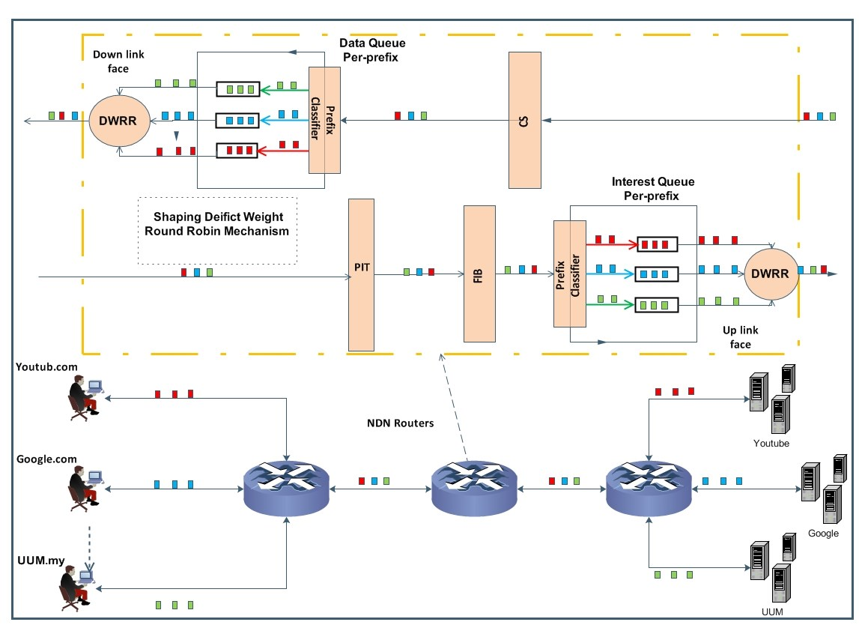
Figure 1: SDWRR Model
As in Figure 1 this Study adapted DWRR scheduler by classifies the different flow based on the content name prefix , and the queues head classified into Data queue and Interest queue to differentiate the shaping weight. Also, the calculation of the quantum of each queue is calculated based on weight assign to each flow as in Algorithm 3. Each queue of an out interface associated with a queuing monitoring scheme to monitors each incoming packet and stamp its arrival time and it procedure is listed in Algorithm 1. In departure, the scheme gets the stamped time to calculate the sojourn time of the packet.
Weighting scheme will evaluate the sojourn time of each queue and check if one of the queue sojourn time exceeds a threshold the scheme will stop sending a packet to the queue. For that, a notification signal will be sent to downstream to slow down its sending rate. Otherwise, the sojourn time of each queue will be calculated to assign the weight of each queue and use it to calculate the shaping rate by SDWRR dequeue scheme.
SDWRR is taking the sojourn time or the weight of the Data queue in down-link of the same prefix to shape the Interest forward rate as in Algorithm 2. As when the sojourn time of Data queue in downlink increase, the Interest rate will decrease and if it decreases the Interest rate increase. Meanwhile, Data rate in SDWRR controlled by assigning fix weight for Data queue to overcome the shaping.
As SDWRR considered many components and schemes in it is procedure we discuss and analyzes each component of SDWRR in detail. Firstly, for simplify the analysis we give each component in our mechanism a notation as follow:
Consumers and Interest packets generation: Let us consider U = {1,...,u} as a set of consumers, where consumer node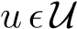is associated with congestion avoidance algorithm for generating and adjusting Interest packets. The consumer node starts generating and sending Interest packets in the network with initial window size w_{u}.
Router: We denote R = {1,...,r} as a set of all routers available in the transmission path between consumer and producer server, where each router connected to some other node(s) via an intermediate link(s). We denote L_{r} = [1_{r},....,l_{r}} as a set of links associated to node r, where each link has capacity C_{l}, for 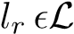_{r}. Furthermore, we denote F_{r} ={1_{r},...,f_{r}} as the set of the interfaces associated to router r, connecting r to another nearby node(s) using intermediate link(s)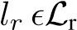.
Router Queues: We consider that each router r has a queue q in each interface 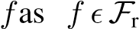 denote as q_{f} and each interface in router associated with Deficit Round Robin (DRR) network scheduler that allocates queue to each outgoing prefix P = {1,....,p}denote as q_{fp}. Each Queue associated with the queuing scheme to calculate the queuing sojourn time ST of each packet in the queue and each queue ST should not exceed a certain time threshold τ.
Flow: We use X = {1,.....,x} to denote the flow rate of Interest packet I and corresponding Data Packet D as pairs, where flows are distinguished by looking to prefix names that are common to all Interests/Data of the same object. The incoming packets are classified into flows and queued in an outgoing queue based on their prefix names as Interests/Data of the same flow queued in different outgoing interfaces. In addition, x_{pi}(t) donate it as the incoming Interest rate of prefix p in the router r.
Secondly, describe the communication in the proposed mechanism starts by assume router r receive packet for prefix
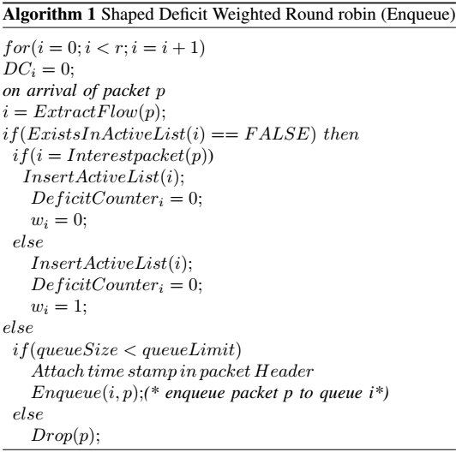
p through interface f in rate X_{p}(t). Router r firstly check the header packet and divide its action as follow:
- If it is Interest packet, the router examines if Interest packet can be satisfied from cache else forward it to PIT. When PIT received the Interest packet it records it’s coming interface and check the FIB to get the available outgoing interface f. After that, send the Interest to DWRR of that interface.
- If the received packet header is Data packet, router check if it is marked add a flag in PIT to inform the weighting scheme to decrease the forwarding rate of the related prefix. Else Data packet sent to DWRR of each interface request same Interest packet.
DWRR associated with three stage to forward each received packet stated as follow:
Enqueue stage: as in algorithm 1 when packet arrive to interface check it is header, if it new DWRR will create a new queue in each available outgoing interface denote as q_{fp}. If it is not new DWRR will forward to its queue. Before enqueue received packets to the queue q_{fp} DWRR will check the queue if not exceed time threshold τ packet enqueue to queue q_{fp} and stamp enqueue time to head of the packet. If queue exceed time threshold τ DWRR will check if it is Data packet the scheme sends NACK to the interface of the congested queue, else scheme will mark Data packet of the same prefix to send it to all interfaces request the same Interest packet.
Weight calculation stage: the proposed mechanism will examine the header if it is Interest packet the weight w_{p} of queue assign as the sojourn time of Data queue of same prefix ST_{pD} in down link queue interface q_{fp} and if header is Data packet the weight will be w_{p} = 1. The Interest packet weight w_{p} calculation done by calculating the Data queue sojourn time of the same prefix in down link. Since Interest packets of same prefix p may sent from many consumer u and received through different interfaces f in router r, NDN

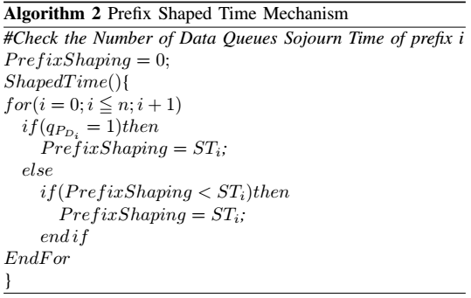
router procedure will forward the first Interest to up link only as one flow prefix and store nonce and incoming interface of the other in PIT. When Data packet received, router will copy the Data packet and forward back to each down link interface that Interest packet received from it. Thus, DWRR create data queue in each down link interface and the weight scheme will calculate the shaping time see (algorithm 2 ) by take the minimum sojourn time of these Data queues as follow:
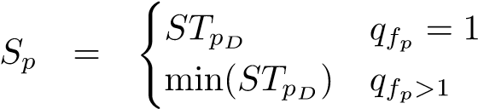 (1)
Third stage dequeue as in algorithm 3: this stage has two sub stage of calculation the weight calculation and scheduling:
Weight calculation: after taking minimum sojourn time of Data queue to shape the Interest queue, forward weight of each queue prefix q_{fp} will be calculating as Eq (2). By checking the head of packet in the queue if it is Data packet the weight of the queue remains as w_{p} = 1 else the weight calculation follow the Eq (3) that act as shaping rate.
Before shape the Interest rate DWRR will check the interface if it is receiving any congestion the weight will calculate base on the flag type if it is marked Data or NACK else calculate shaping rate base on the Data queue sojourn time of that prefix.
(
M Header = Interest
w_{p} = (2)
1 Header = Data
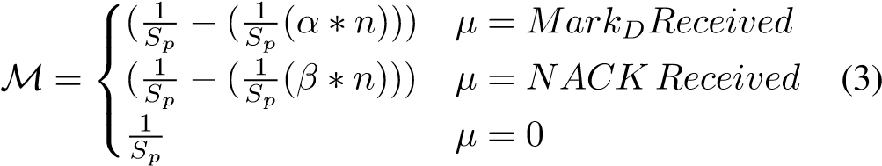
Scheduling stage start calculate forwarding rate of each prefix in the interface f_{n} by sum the weight of each queue in the interface q_{fp} as Eq (4). After calculating the weight and sum it DWRR scheduling scheme will start calculating quantum k that denote as k_{qp} and deficit counter DC_{qp} of each prefix queue in interface as Eq (5) and Eq (6).
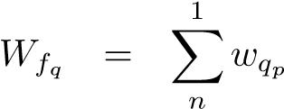 (4)
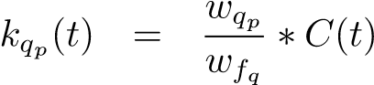 (5)
DCqp = kqp + DCqp (6)
When the deficit counter of each queue has calculated the procedure of dequeue begin by check the packet size in the head of the queue if it is less than or equal of the deficit counter. Therefore, each packet transmitted to up-link the deficit counter is reduced by the number of bytes in the packet. The rest of deficit counter subtraction compare with the following packet, and if deficit counter subtraction more than the packet size will be transmitted again else, the subtraction will keep as deficit counter for the queue to next round and start to queue from the next queue.
Before dequeue packet, the sojourn time ST_{qp} of the queue q_{fp} will be calculated using Eq (7)by detach the stamped time on the head of the dequeued packet and subtract it by the time of dequeue.. After that, DWRR will check if it is Interest header will update the ST_{pI} else update ST_{pD}. When the ST_{pI} update it mechanism will check if ST_{pI} is less than threshold mechanism stores the ST_{pI} normally if not will mark incoming data and forward it to downlink to decrease the sending rate as Eq (8). Similar to ST_{pI}, ST_{pD} will checked and if it’s above threshold mechanism will send a NACK to downlink as Eq(9).
STqp(t) = Tout − Tin (7)
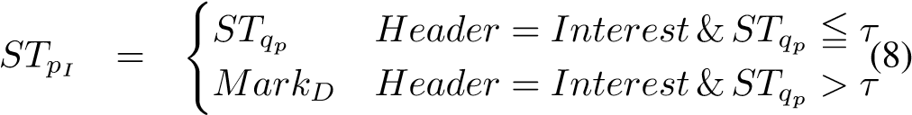
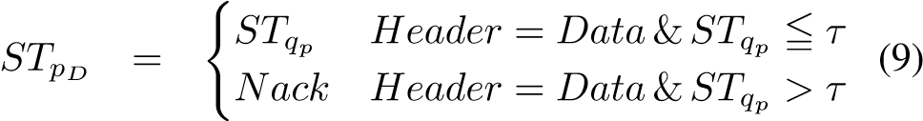

RESULTS AND DISCUSSION
To verify the efficiency of the proposed mechanism, we conduct several simulation-based experiments in various scenarios using ndnSIM [19] to indicate the effectiveness of its behaviors. Each consumer associated with a control mechanism to control Interest rate in consumer side and each router associated with SDWRR mechanism to control the forwarding rate and prevent the congestion in the router, in addition, the router queue size 1000 packets and simulation time will be 120s in all following scenario. Thus, evaluate done by comparing it against HIS mechanisms that are related work with the proposed mechanism. .
A. Scenario 1
We take the topology illustrated in Figure 2, which is the dumbbell topology for the congestion, as our experiment topology. Four consumers request different content under different prefix from different producer through the same router and

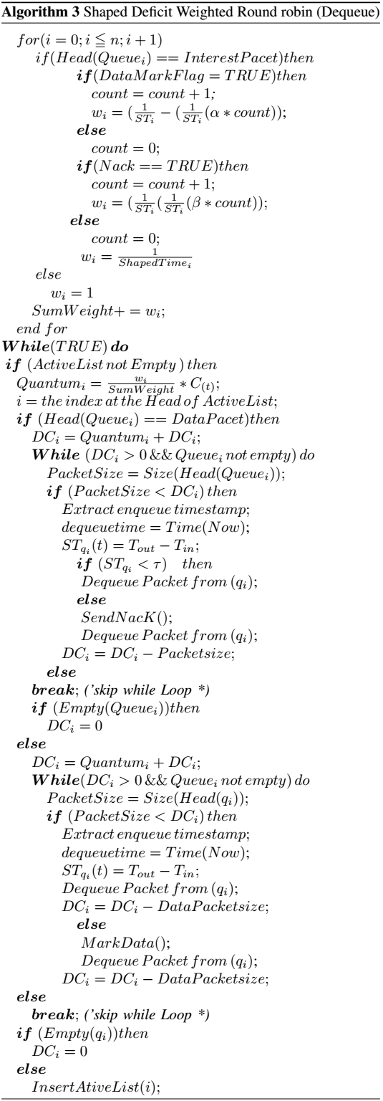

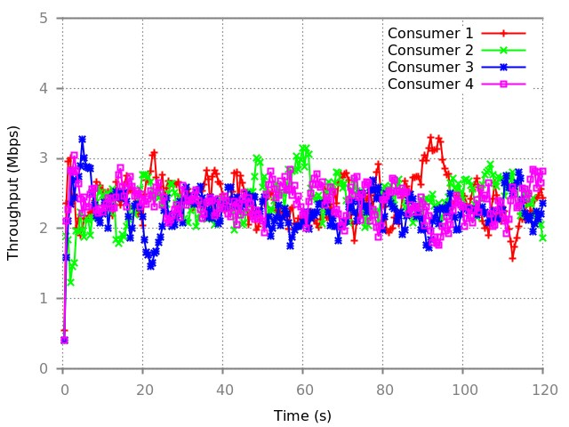
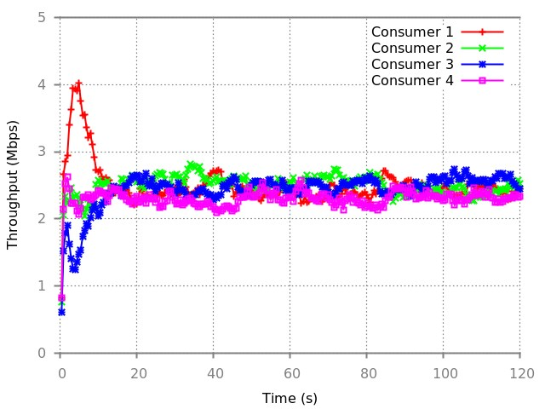
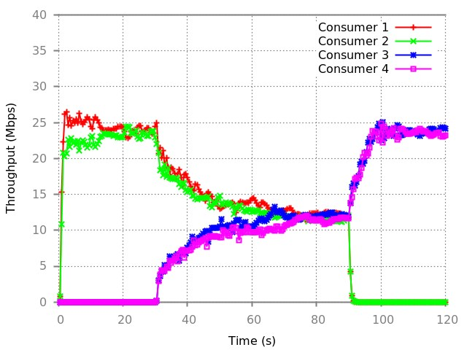
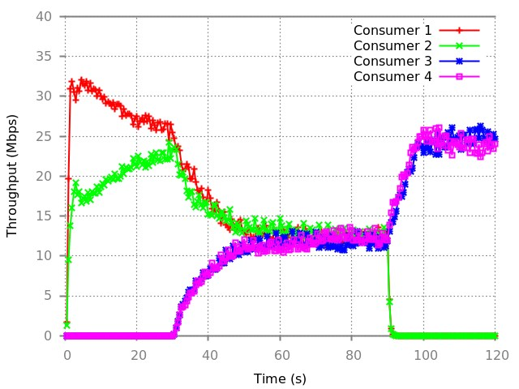
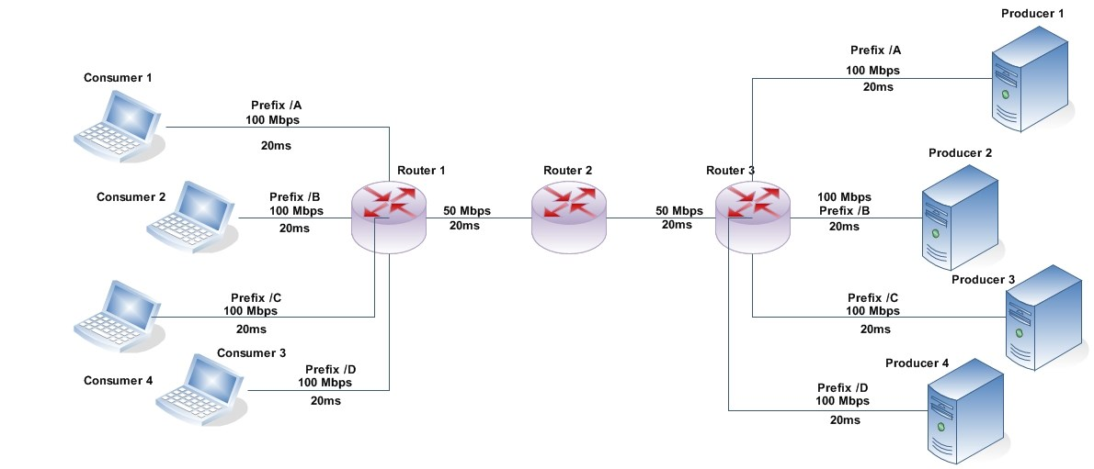
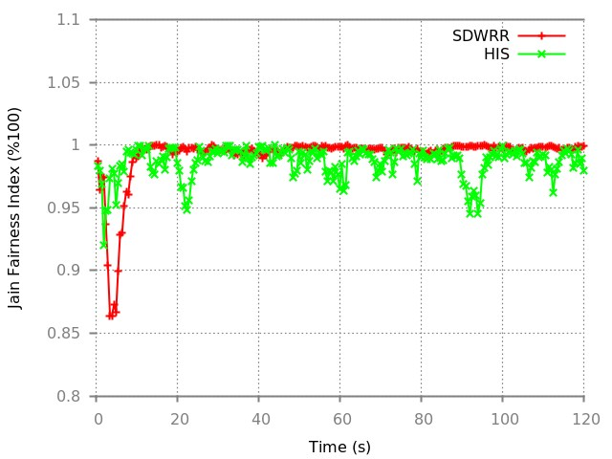
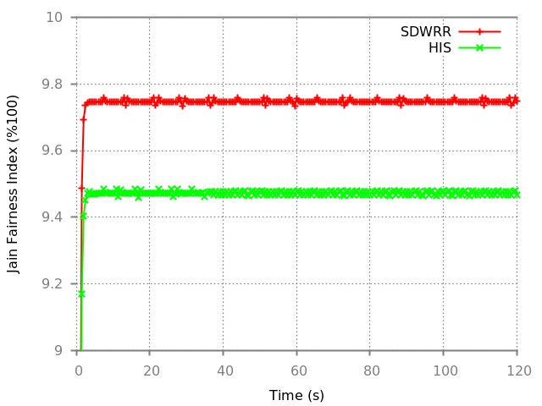
Figure 2: Dumbbell Topology
(
a) Jain Fairness Index
(
b) Bottleneck Utilization
(a) HIS (b) SDWRR
Figure 3: Different bandwidth scenario
each consumer connected to the router using different link as u₁ = 100Mbp, u₂ = 25Mbp, u₃ = 25Mbp and u₄ = 50Mbp and r₁ connected to r₂ with capacity link 10Mbps and r₂ connected to each producer using link capacity 100Mbps . This scenario is it check how the mechanism deals with fairness and throughput between a different consumer in the bottleneck router.
As results show in Figure 3 (a) HIS attempt to fairly divide the bandwidth but the irregular variation rate between consumers decrease the fairness between them. While in NDN the arriving time of data is not constant and HIS depend on it to shape the sending rate some consumers try to take more bandwidth than the other and affect the sharing fairness as it shows in Figure 4.(a). Also, the irregular rate effect the link utilization as can be seen in Figure 4.(b) how he utilizes nearly 95% of that bandwidth only. On the other hand, as SDWRR depend on the internal parameters to shape the rate, it performs better in fairness, as shown in Figure 3.(b) the flat rate between the consumers. Furthermore, Figure 4.(a) conforms to the fairness of SDWRR as the fairness index is nearly 100%. As a result, figure 4 (b) shows, SDWRR utilize nearly 97.8% of the bandwidth.
- Scenario 2
The same topology in Figure 2 with some change in starting and stopping time to examine the mechanical adaptation of different consumer behavior and how the mechanism will forward the packets to uplink with fairness-based prefix weight. Consumers start time will be as follow u₁ = 0s, u₂ = 0s, u₃ = 30s and u₄ = 30s. In addition, the stop time of each consumer will be u₁ = 90s, u₂ = 90s, u₃ = 120s and u₄ = 120s.
Figure 4: Different bandwidth scenario
  - HIS (b) SDWRR
Figure 5: Different starting time starting scenarios
Figure 5 shows how both mechanisms adapt the forwarding rate when consumer 1 and 2 start forwarding their Interest packets. As SDWRR have two types of congestion notification, it will adapt the rate faster than HIS, as shown in Figure 5.(b) it takes less than 20s to adapt the rate. HIS will notifies the consumer to decrease the rate only after trying to shape the traffic in the router. If Interest queue is congested will sent the notification to the consumer, and this takes a long time as it shows in Figure 5 (a) that HIS takes more than the 40s to adapt the rate.
- Scenario 3
Data packet size of each prefix will be a change in this scenario to measure the fairness between the different prefix when they share the same interface. The setup of the topology link showed in Figure 2 and the simulation time will be 120s. Producers will generate a Data packet size to each prefix as follow p₁ = 1024Kbs, p₂ = 1024Kbs, p₃ = 500kKbs and p₄ = 500Kbswhen every Interest packet arrive.
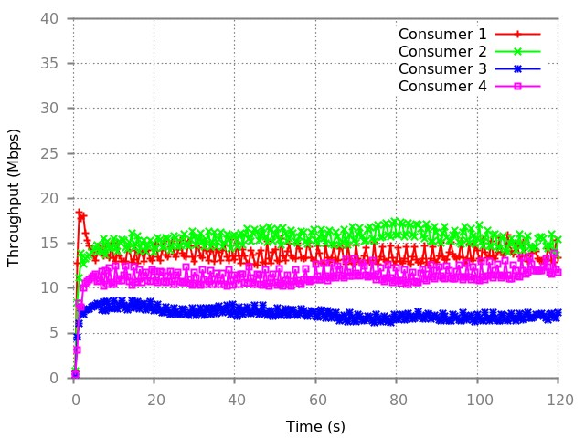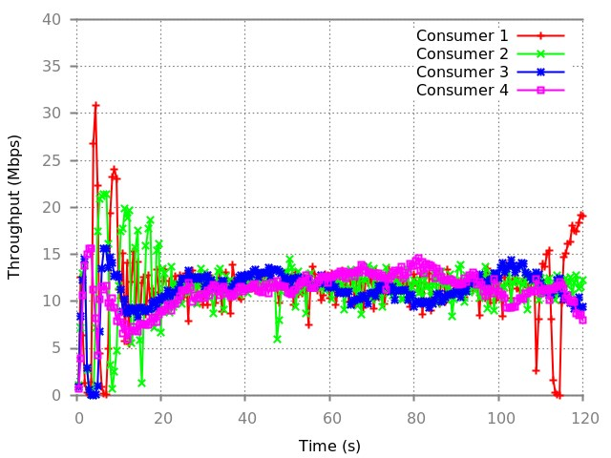
  - HIS (b) SDWRR
Figure 6: Different packet size (Bandwidth Utilization)
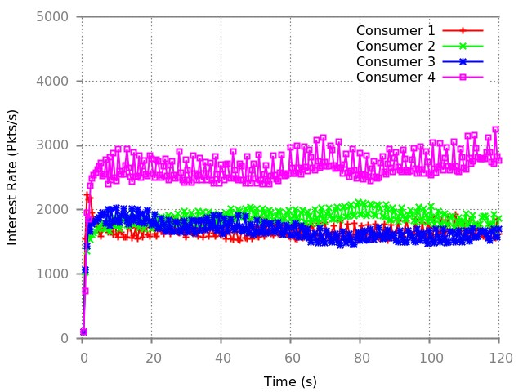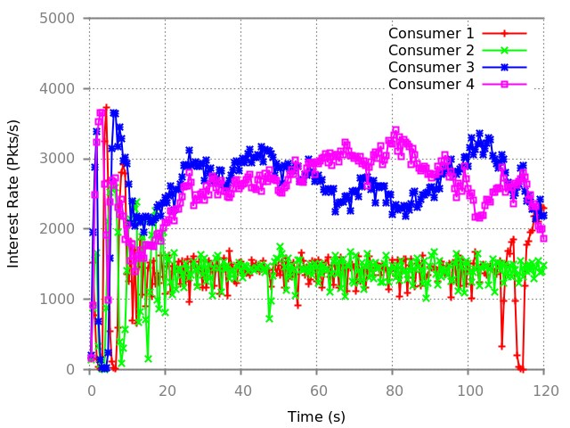
(a) HIS (b) SDWRR
Figure 7: Different packet size (Interest packet rate)
While in this scenario, consumer 3 and 4 should have the double rate of consumer 1 and 2. Figure 6.(a) shows how poorly HIS preform when it received packets with different size as it gives each consumer the same rate to forward there Interest packets that show in Figure 7(a). Furthermore, as SDWRR forward the packets based on the quantum that assign fairly to each consumer will not affect if there a variant of packets size as shown in figures 6.(b) and 7.(b).

CONCLUSION
In this paper, SDWRR is proposed to control the future rate of Data packet in NDN router by shaping the rate of Interests packets that send to up-links. SDWRR dynamically adjust the Interest sending rate by monitoring the packets sojourn time of Data queue on the downlink. Thus, SDWRR does not need to know the bandwidth or RTT of the links to shape the forwarding rate. In addition, SDWRR applies the bit by bit scheduling to ensure the fairness between the different size of packets. Because of these characteristics, SDWRR is let different flow fairly share the bandwidth as it does not affect from RTT variation or the different size of Data packets. SDWRR is implemented in ndnSIM to validate and evaluate its performance, and it shows that it has promising results. As it shows fast rate adaptation in sharing the bottleneck links with nearly full utilization of the bandwidth. Nevertheless, the SDWRR result shows how it not affected if it is different in the size of the Data Packets and give each flow fair bandwidth to utilize.

REFERENCES
- L. Zhang, D. Estrin, J. Burke, V. Jacobson, J. D. Thornton, D. K. Smetters, B. Zhang, G. Tsudik, D. Massey, C. Papadopoulos, et al., “Named Data Networking (NDN) Project,” NDN-0001, Xerox Palo Alto Research Center-PARC, 2010.
- C. Yi, A. Afanasyev, I. Moiseenko, L. Wang, B. Zhang, and L. Zhang, “A Case for Stateful Forwarding Plane,” Computer Communications, vol. 36, no. 7, pp. 779–791, 2013.
- Q. Chen, R. Xie, F. R. Yu, J. Liu, T. Huang, and Y. Liu, “Transport control strategies in named data networking: A survey,” IEEE Communications Surveys & Tutorials, vol. 18, no. 3, pp. 2052–2083, 2016.
- G. Carofiglio, M. Gallo, and L. Muscariello, “ICP: Design and Evaluation of an Interest Control Protocol for Content-Centric Networking,” in Computer Communications Workshops (INFOCOM WKSHPS), 2012 IEEE Conference on, pp. 304–309, IEEE, 2012.
- S. Salsano, A. Detti, M. Cancellieri, M. Pomposini, and N. BlefariMelazzi, “Receiver-driven interest control protocol for content-centric networks,” in Proceeding of ACM SIGCOMM Workshop on Information Centric Networking (ICN), 2012.
- M. Amadeo, A. Molinaro, C. Campolo, M. Sifalakis, and C. Tschudin,
“Transport Layer Design for Named Data wireless Networking,” in Computer Communications Workshops (INFOCOM WKSHPS), 2014 IEEE Conference on, pp. 464–469, April 2014.
- T. Fu, Y. Li, T. Lin, H. Tan, H. Tang, and S. Ci, “An effective congestion control scheme in content-centric networking,” in Parallel and Distributed Computing, Applications and Technologies (PDCAT), 2012 13th International Conference on, pp. 245–248, IEEE, 2012.
- K. Schneider, C. Yi, B. Zhang, and L. Zhang, “A practical congestion control scheme for named data networking,” in Proceedings of the 3rd ACM Conference on Information-Centric Networking, pp. 21–30, ACM, 2016.
- M. Wang, M. Yue, and Z. Wu, “Wincm: A window based congestion control mechanism for ndn,” IEEE International Conference on Hot Information-Centric Networking (HotICN 2018), 2018.
- F. Zhang, Y. Zhang, A. Reznik, H. Liu, C. Qian, and C. Xu, “A Transport Protocol for Content-Centric Networking With Explicit Congestion Control,” in Computer Communication and Networks (ICCCN), 2014 23rd International Conference on, pp. 1–8, IEEE, 2014.
- N. Rozhnova and S. Fdida, “An Effective Hop-by-hop Interest Shaping Mechanism for CCN Communications,” in Computer Communications Workshops (INFOCOM WKSHPS), 2012 IEEE Conference on, pp. 322– 327, March 2012.
- Carofiglio, Giovanna and Gallo, Massimo and Muscariello, Luca, “Joint Hop-by-hop and Receiver-Driven Interest Control Protocol for ContentCentric Networks,” in Proceedings of the second edition of the ICN workshop on Information-centric networking, pp. 37–42, ACM, 2012.
- Y. Wang, N. Rozhnova, A. Narayanan, D. Oran, and I. Rhee, “An Improved Hop-by-hop Interest Shaper for Congestion Control in Named Data Networking,” ACM SIGCOMM Computer Communication Review, vol. 43, no. 4, pp. 55–60, 2013.
- S. Mejri, H. Touati, N. Malouch, and F. Kamoun, “Hop-by-hop congestion control for named data networks,” in 2017 IEEE/ACS 14th International Conference on Computer Systems and Applications (AICCSA), pp. 114–119, IEEE, 2017.
- T. Kato and M. Bandai, “Congestion control avoiding excessive rate reduction in named data network,” in Consumer Communications & Networking Conference (CCNC), 2017 14th IEEE Annual, pp. 108–113, IEEE, 2017.
- T. KATO, M. BANDAI, and M. YAMAMOTO, “A congestion control method for named data networking with hop-by-hop window-based approach,” IEICE Transactions on Communications, 2018.
- R. Adams, “Active Queue Management: A Survey,” Communications Surveys Tutorials, IEEE, vol. 15, pp. 1425–1476, Third 2013.
- R. Ouni, J. Bhar, and K. Torki, “A new scheduling protocol design based on deficit weighted round robin for qos support in ip networks,” Journal of Circuits, Systems and Computers, vol. 22, no. 03, p. 1350012, 2013.
- S. Mastorakis, A. Afanasyev, I. Moiseenko, and L. Zhang, “ndnSIM 2.0: A new Version of the NDN Simulator for NS-3,” Technical Report NDN-0028, NDN, January 2015.

