Energy-Aware Multipath Forwarding Mechanism for Named Data Network in Wireless Environment
Suhaidi Hassan
InterNetWorks Research Lab School of Computing
Universiti Utara Malaysia
Sintok, Malaysia
suhaidi@uum.edu.my
Sarah Hamdi
InterNetWorks Research Lab School of Computing
Universiti Utara Malaysia
Sintok, Malaysia
alanesi.sarah@gmail.com
Mohammed Alsamman
InterNetWorks Research Lab School of Computing
Universiti Utara Malaysia
Sintok, Malaysia
alsamman@internetworks.my

Abstract— Named Data Networking (NDN) is an evolving network of Internet architecture uses a modern paradigm of network connectivity focused on the identity of content on the Internet. By naming data instead of locations, the NDN changes the basic network service abstraction from delivering packets to destinations to retrieving the named data. In wireless network environments, NDN faces two main challenges namely limitation of battery power and intermittent connectivity. Due to the energy limit, the nodes soon die or become congested if they have low residual energy, high transmission rate, or limited Pending Interest Table (PIT) space. The aim of this study is to propose a forwarding mechanism called Energy-aware Multipath Forwarding Mechanism (EMFM) to forward incoming interest packets in order to reduce the usage of energy in the nodes thus sustaining the network’s lifetime. EMFM considers nodes’ battery power and PIT size into account to predict the next forwarding hop in the overall packet transmission process. A simulation was conducted using the ndnSIM tool to design and evaluate EMFM and compared with On-demand Energy-based Forwarding Strategy (OEFS). The outcome of this study is significant to demonstrate that EMFM can enhance the network lifetime of NDN wireless nodes.
Keywords—Named Data Networks, Wireless Network, Forwarding Strategy, Energy Consumption.

INTRODUCTION
In recent years and decades past, the Internet has observed
different forms of semantic redistribution and involvement of
new concepts. Thus, enabling the accommodation of more
users and device interactions to the outer world to access
multi-services and numerous versions of information. Moreover, Internet has connected billions of gadgets with large heterogeneity in their respective functionality, examples such as mobiles, tablets, wireless sensor devices, actuators, smart home appliances, and several more wired or non-wired physical objects that interact and establish good cooperation’s among their peers and other things/objects. This aids in the provision of an intuitive content-based application or service with a common goal of creating a smart world [1].
As a result of the significant increase in the usage of
social networks, digital media, e-commerce, and smartphone applications, becoming essential to deal with the Internet as
a distributed network. Recently both peer-to-peer (P2P) and
content delivery network (CDN) architectures are used as
a platform for content-centric networks to achieve the purposes. Nevertheless, for the future application requirement, these solutions are not considered to be good enough. Based on the futuristic perspective, it’s vital to develop a new Internet architecture that can handle all the upcoming applications requirements, whereas it's noticeable that most of the current solutions usually adopting the basic models based on wired Internet protocol stack and IP assignment to mobile ad-hoc node [2], [3].
In order to handle these needs, the Information-Centric Network (ICN) has been branded as a new Internet architecture that can shift Internet architecture from host to host to a receiver-driven architecture [4]. In ICN, the focus of the communication paradigm is on the content and change the perspective from (where) to (what). The interest in ICN has increased significantly among both academic and industrial institutions [5]. Also, ICN offers an enhancement of several areas of content retrieval, including mobility, protection, scalability, and efficiency [6].
Compared to the existing architecture, it is obvious that the ICN paradigm does not support additional control overheads such as add-on safety mechanisms, address resolution, and congestion controls. Several ICN-active projects in the world are running in this sphere, for example, PURSUIT, 4WARD [7], [8], and CCN [5]. Between each one of these projects, the named data network received the biggest attention among the research community after Jacobson’s revolutionary paper been released [9], [10].
NDN is found to be both faster and simpler for communication operations and yet it is found to be replacing the existing IP architecture with named content. Even though, the latest three decades of constant effort in respect to both fortes and limitations of the existing Internet architecture, NDN offers integral strong functionality such as in-networking caching, security primitives, multipath routing, and flow balance mechanisms. Moreover, names are used to uniquely identify every piece of content and the communication is primarily focusing on the content manes separated from their location [9], [10].
Architectural NDN has two distinct types of messages Interest and data packets are to be used for correspondence purposes. In addition, three distinctive table types are to be used to make precise determinations by Interest and Data packets. These tables are referred to as the Content Store (CS), the Pending Interest Table (PIT), and the Forwarding Information Base (FIB). In CS, data packets composing content are cached for future usage. In comparison, the PIT table is commonly used to control packets of interest. It usually holds all pending request entries that are required for relevant data packets from other nodes. In comparison, the FIB table is used for forwarding. It consists of the data on the interface and loaded with both incoming and outgoing using a routing protocol capable of modifying it periodically. The process of canonical communication in the NDN is done. by consumer node as it is responsible for sending an Interest packet to a provider node to get a Data packet. NDN nodes require an appropriate traffic control mechanism as multiple subscribers bid for the same connexon or multiple resources that can contribute to node battery drain and PIT inundated. For that, the packet Interest will be dropped or retransmitted that increase the delay of fulfilment the Interest packets.
This paper describes the Energy-aware Multipath Forwarding Mechanism (EMFM), and how to achieve acceptable utilization at the same time provide high network performance. Also, explains how the design and implementation of EMFM considered the battery and PIT of the node in selecting an appropriate path in wireless ad-hoc networks that extends the network’s lifetime, takes care of the connectivity, and satisfies delay constraints.

RELATED WORK NDN
Researchers have recently implemented many forwarding
strategies to address increasing challenges in the wireless
network and are thus one of the most significant technology networks that demonstrates architectural strength and
deployment platter type connectivity for large applications.
M. Amadeo [11], a more versatile device architecture was
suggested for accurate recall from various wireless sources
based upon data suppression, data collision prevention, and
interest in the carriage of data in interest packets. However,
it was noted from the proposed system that the study was
primarily suited for wireless single-hop architecture. In [12],
[13], interest packets forwarding based on multi-hop network
formats are concise. A delayed-time blind flood was planned to detect possible suppliers in [14]. Moreover, based on [15],
each NDN node maintains a path during a blind flooding
transmission during the data packet forwarding to encourage
future forwarding of interest. Similarly, in [13] simple blind and complete transmission support reactive Positive Name-based Routing (RONR) and Vanilla Interest Forwarding (VIF).
Ad-hoc NDN wireless network research has focused largely on vehicle communications. Reactive transfers on named wireless ad-hoc data networks can be divided into two categories, according to the survey conducted: blind forwarding and awareness-based forwarding [16]. Blind forwarding with timer-based packet deletion schemes for the purpose of controlling interest forwarding and avoiding broadcast storms[17], [18]. The authors create a collision avoidance approach based on a uniform random timer in [18] to help the dissemination of NDN-based V2V traffic information. Furthermore, in [18], a constructive data-push method is being proposed to speed up data spread, which varies in the original NDN concepts. Nevertheless, [19] suggested an energy transport strategy (OEFS) ad-hoc protocol to take into consideration the node of residual energy in the transmission process.
Likewise, timers and packets repression were suggested to
prevent packet collisions in the NDN-based vehicle setting
in [17], [14], [20]. The delayed Interest packet time frame
is longer than the Data packet time frame for which Data is
given higher priority over the Interest packets. In addition, the above blind transport systems are based on a uniform random timer, while this proposal's deferred timer consists of intermediate nodal residual energy and does not blind the transmission on a flood basis too.
On the other hand authors in [17], [14], [20], [21], [22]
selects next transmitters based on the understanding of network-related information, such as the distance of transmission, message Redundancy, geo-location, and data retrieval rate.
The main concept of aware forwarding is to pick the next forwarders. The authors in [22][ proposes to select the farthest
node on each quadrant as the forwarding sponsor by sharing
information between senders of interest and recipients of
two widespread types of messages. Exchanging dedicated
information for the collection of relay nodes will make the system more complex. The deferred time frame dependent
on the transmission distance that provides for the farther
nodes a greater priority for the forwarding of interests without
exchanging additional information in a Dual Mode of Interest
(DMIF), [23]. In Neighborhood, Aware Interest Forwarding
(NAIF) scheme [24] is based on two main historical factors:
the data recovery rate and the forwarding rate. The relay
node choices are based on two significant historical factors.
The first is the proportion between the number of packets
of data successfully recovered and the number of packets
of interest sent. The second represents the fraction of the
incoming packets of interest that a given node sends.
Disseminating communications over a wireless NDN network with a limited number of transmissions; a Gossip algorithm called BlooGo [21] is built in. The principle behind this definition is that the message can only be transmitted by a relay node if its vicinity4 is not specifically included in the senders. The analogy is carried out based on a bloom filter. In short, the above-known transmission systems need additional algorithms for choosing the relay nodes, while the known transmission in the DMIF relies on the information left without extra overhead in the passing data packets. A Provider Aware Forwarding (PAF) framework for direct interest forwarding following the blind flood in literature has been built by the authors [17], [14], [20]. The distance between the local node and the potential providers of content is maintained by a distance table by either node. The consumer selects the closest one after several data packets have been obtained and maintains the provider ID and the duration information for future interest packets. Intermediate node will transmit the interest to the direction of the chosen provider.
Since the fundamental principle of information, transfer lies in the selection of potential forwarders or service providers. Providers focused on understanding the network data such as the distance of transmission, redundancy of messages, rates of location, and data recovery [17]. However, the battery energy was included in [19], but it was ignored the node charge which mainly affected the faster power drainage. Moreover, much research on Internet transmission on wireless networks of name data was performed, but the energy sources were less concentrated [23].

ENERGY-AWARE MULTIPATH FORWARDING MECHANISM
EMFM was enhanced mechanisms that measure the remaining energy and PIT level of a neighbor node to give a
percentage weight for each node and keep it in the FIB for
use in every next forwarding decision. EMFM adds two bits
to a data packet to report node battery energy and the PIT
level to the down nodes. The EMFM selection considers all
the next-hop nodes and checks the value of their remaining
energy and PIT levels recorded in the FIB; the path with the highest battery capacity and lowest PIT level is selected. The
other paths are classified based on the battery level and PIT
occupancy. If a forward node does not have the highest battery
level and the PIT becomes congested, packets are forwarded
to the next classified path in node to utilize the network’s
resources. As the network has heterogeneous nodes with different PIT and battery capacity, each node will normalize
the maximum capacity of the battery and PIT and record it
to return data packets. This mechanism thus answers the first
of the research questions, highlighting the direct influence of
battery and PIT load on network performance. Therefore, the
main goals of EMFM are:
- To increase the lifetime of the networks.
- To balance nodes and achieve high resource utilization.

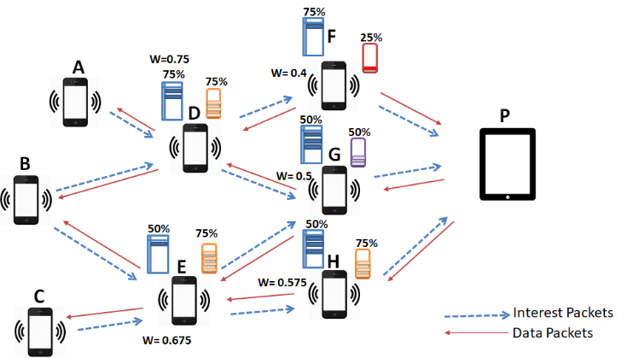
Fig. 1. EMFM Model
For example, the loss of connection occurs because of increasing the load on the node until its battery is drained. As
Figure 1 shows, node B represented as a consumer and needs to receive content from the producer P. Nodes D and E represent as paths to producer P. Nodes A and C are consumers participating in the network and they are interested in different content from node P. While node B has two paths to move the data from P, it has the advantage of sending the interest in multipath mode.
For that, if node B sends its interest on one of these paths, for example, the path from node D while node A uses the same path, node D will receive heavy traffic from the two nodes, this will give node D a traffic high transmission rate, causing it to lose its residual energy and being drained, affecting the return of the desired data to nodes A and B. As a result, the network performance will degrade from the loss of the connection node.
Using EMFM that takes the battery energy and PIT load to forward the interest packet. Consumer B will follow this scenario: if node B acts as the consumer node and needs to get the data from node P it has the two paths to reach node P. The first is through node D and the second through node E. For the first interest, node B will check if there is any power and load the records for nodes D and E in the FIB table to forward accordingly. If there is no record, node B will send the interest to all paths until it receives the first data packet from each path and forwards it to the next interest base as determined by the weight of each path. For example, if node C forwards packets to node E, node B will forward packets using path D, as shown in Figure 1, because node D has a higher weight than node E; and node D will forward the packet to node G because node G has a higher weight than node F, and will forward it to the producer node P and the data packet take the revers path to node B.

EMFM ANALYSIS
EMFM uses battery strength and PIT occupancy to make the forwarding decision. Each node monitors the remaining energy of its battery and PIT level occupancy to compute the energy drain rate for every T second sampling interval. To minimize the intricacy of heterogeneous nodes with different PIT and battery capacity, nodes are normalized to the maximum capacity of the node battery and PIT by as follows.
- Normalized node’s battery level (E[E]) is defined as the ratio of the remaining energy (RE) to the maximum
energy level ($MaxE$).
$E\left[E\right]=\frac{RE}{MaxE}$( 1 )
- Normalized node’s PIT load (E[P]) is defined as the remaining ratio of the current PIT size (CP) to the maximum PIT load ($MaxP$)
$E\left[P\right]=\frac{CP}{MaxP}$( 2 )

In order to better reflect the current state of energy spending, we give higher priority to the present sample drain of nodes, ${DR}_{i}$ rate for node $n_{i}$ to show the remaining battery when the $n_{i}$ node is drained, i.e. how long the $n_{i}$ node will hold up with routing activities focused on local traffic conditions on its amount of residual energy and PIT level. The related expenditure it is possible to describe a function as:
${DR}_{i}=∝{E\left[E\right]}_{i}+ β{E\left[P\right]}_{i}$( 3 )
EMFM effectively combines two parameters with weighing
factors α; β and based on the normalizing criteria values and using weights of importance ranging from “0” to “1”. In this study, the ${DR}_{i}$metric value as in Formula (3) set the assumption to importance weight for battery power and PIT to α = 0:6 and β = 0:4 as energy is critical in wireless networks and should have more weight than other PITs [25].
The EMFM is based on selecting the path $r_{M}$, contained in the set of all possible path $r_{P}$ the next hop, that presents
the highest maximum lifetime value, that is:
$r_{M}=r_{P}=\max_{∀r_{i}∈r}{DR}_{i}$( 4 )
Due to changes in the energy drain rates at nodes, the status of the chosen path will change over time; a new route performance relies on the forwarding mechanism. To incorporate EMFM in the wireless forwarding mechanism, all nodes consistently should have a new route that takes account of the continually changing power conditions of network nodes.

EMFM EVALUATION
The proposed mechanism implemented in ndnSIM [26]
with two evaluation scenarios. First, one consumer and one
the producer was added and the number of intermediate nodes
changed. Secondly, the number of producer and consumer
pairs were increased, with a constant number of intermediate nodes.

Experimented Steps
The default interest and data packets used in ndnSIM
were connected using the IEEE 802.11g signal, Nakagami
propagation model and the random walk point mobility model
with speed 2-4 m/s in 700*700-meter area. Moreover, every node's energy was set to 100 Joules. The receipt, transmission, and idle state consumption have been set 0.9603W, 1.74W, and 0.6699W. The content was 4,000 data packets, each packet consisting of 1040 bytes with a send rate of 6 Mbps. Simulation time was set to 700s and the results were presented after ten times of running.

Metrics
The performance of EMFM was compared with the OEFS
the protocol proposed for Named Data Wireless Networks, taking the energy residual energy metric as the forwarding decision, which makes it a good candidate for comparison. Even though performance metrics may mean different things to different researchers depending on the context, this study will consider three performance metrics:

Content Download Time: It is known as the average time taken by the user to download all data packages of one content[19] and is calculated as following formal:

$T_{i}=T_{0}-T_{n}$( 5 )

$D_{t}=\frac{\sum_{1=0}^{n}{T_{i}}}{n}$( 6 )
Where $T_{i}$is the time that takes to download whole content and $T_{0}$ is the time of first data packet received of the content and $T_{n}$is the time of last data packet received of the same content and $D_{t}$ is the average download time.

Total energy consumption: Defined as the total energy consumed by all nodes during the simulation time [23] and calculated as follow:
$E_{i}=e(b_{r}-b_{s})$ ( 7 )
$E_{Total}=\sum_{i=0}^{n}{E_{i}}$( 8 )

Where $E_{i}$ denotes the total energy consumed by one node in the network and $e$ is a factor indicating the energy consumed per bit at the received node while $b_{r}$ and $b_{s}$ is the number of bits received and send by the node and $E_{Total}$ is the total energy consumption in all networks.

Data Redundancy: known as the average number of replicate data packets the user receives due to NDN caching[19] and calculated as follow:
${ D}_{i}=\sum{d_{i}}$( 9 )

$R=\frac{\sum_{i=0}^{n}{Di}}{n}$( 10 )
Where Di is the sum of di duplicated data packet of one content and R is the average number of duplicated data packet and n is the number of the different content received by the consumer.

Analysis

The efficiency of the two strategies was evaluated by considering the node density and the number of producer and consumer pairs in the network. In Figure 2 EMFM and OEFS are compared based on the content download time. One producer and consumer were used in the simulation scenario.

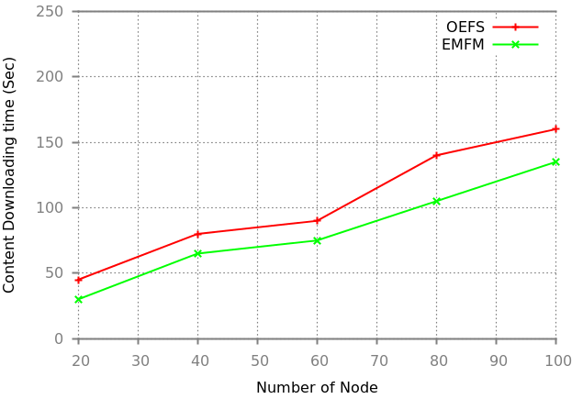
Fig. 2. Content Download Time vs Number of Nodes
As shown in Figure 2, Owing to the larger number of nodes and packets, as the number of nodes increases, the download time increases. Because of the multipath process, the content download time of EMFM was lower than OEFS in the initial stage. When the number of nodes was increased the OEFS took longer because it only acts when the node has insufficient battery energy and reaches the danger state. Converting the node to a lost node affects network performance. On the other hand, EMFM takes the PIT load near the battery energy to forward the packet and prevents the node from reaching the danger stage and being lost to the network.

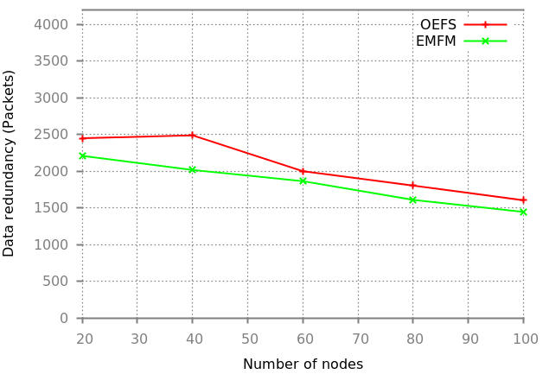
Fig. 3. Data Redundancy vs Number of Nodes
Figure 3 shows the data redundancy performance of the two
strategies. In the initial stage, the performance of both strategies was very similar because there were few participant nodes and their power were still high. The retransmission of interest minimized this but when the number of nodes increased, the overhead increased too. This delayed the returned data packet and caused the consumer to issue a re-transmitted interest. On the other hand, EMFM improved in the following stage because some nodes in OEFS entered the danger state and stopped receiving interest packets, without replying by acknowledgment to the down node. This caused the down nodes to issue more interest packets and more redundant data.

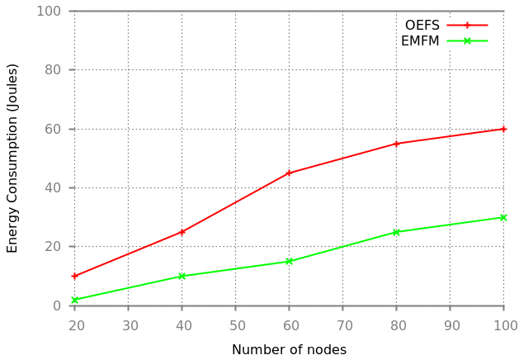
Fig. 4. Network Energy Consumption vs Number of Nodes
Figure 4 shown both strategies evaluated in terms of network energy consumption. EMFM performs better than OEFS
because of the load distribution that EMFM uses to forward
packets. Since the output of the two strategies was assessed by increasing the number of producers and consumers in the network, as shown in Figure 5, we assessed 50 nodes. The download time was evaluated and shown in the initial pair and the two strategies performed almost the same. However, when the pairs were increased from 2 to 5, the performance of EMFM became more reliable because the network had more paths for forwarding that saving the node time. The opposite was seen in OEFS as the network became congested and nodes entered the danger state, and so did not forward the packets and drop them.
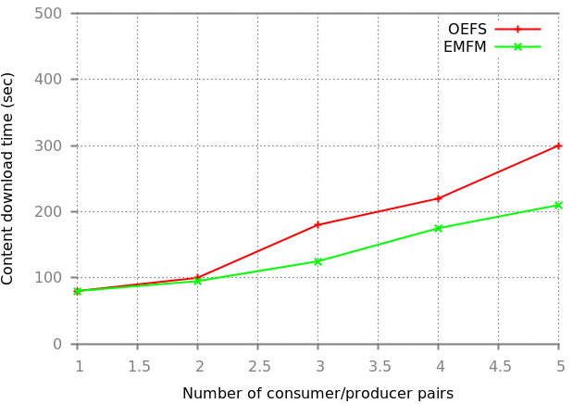
Fig. 5. Content Download Time vs Number of Pairs
In Figure 6 the performance of the two strategies was
measured in terms of data redundancy and showed that both
strategies performed nearly the same. When the number of
pairs increased, the gap between the two strategies widened
and EMFM performed slightly better. Figure 7 shows that
the total energy consumption in EMFM and OEFS increased
when more consumers were added, because of the large number of requests for the content. In contrast with OEFS,
EMFM performed better in terms of energy consumption,
since it supports the flexible mode shift for the interest packets multipath forwarding according to the result of the FIB lookup.
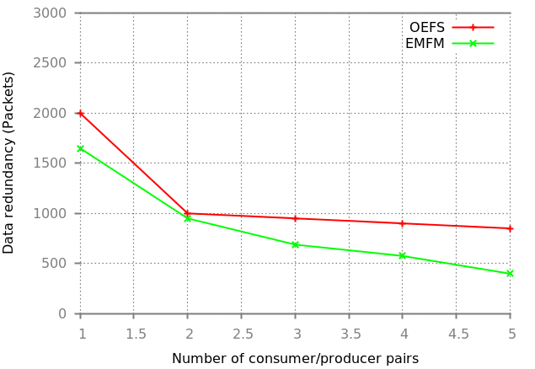
Fig. 6. Data Redundancy vs Number of Pairs

CONCLUSION
The aim of this research paper was to obtain acceptably
medium utilization of networks, at the same time providing
a high level of performance. The NDN layer has the ability
to choose the minimum energy consumption of the next hop
to forward the interest, in order to increase the lifetime of
the network. While forwarding strategy is a balance between
nodes to achieve high resource utilization in a fair manner. A serious problem in selecting an optimal path in wireless ad-hoc networks is energy consumption and extending the network’s lifetime while ensuring connectivity and satisfying delay constraints. For that, EMFM was implemented in this paper to improve network performance in terms of content download time, data redundancy, and network energy consumption. This implementation consists of two components, the remaining energy of the node and the PIT size.

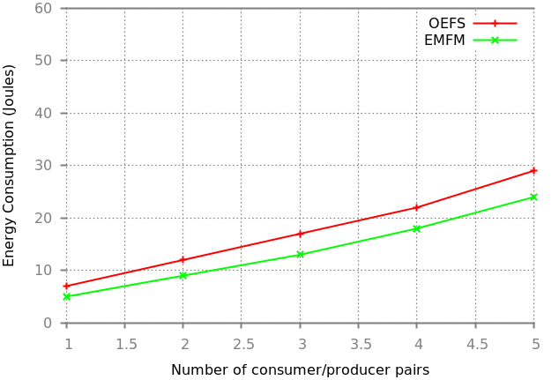
Fig. 7. Network Energy Consumption vs pairs

References

- Cisco-forecast. (2020, March 9) Cisco annual internet report (2018-2023) white paper. Cisco. [Online]. Available: https://www.cisco.com/c/en/us/solutions/collateral/executiveperspectives/annual-internet-report/white-paper-c11-741490.html
- Q. Chen, R. Xie, F. R. Yu, J. Liu, T. Huang, and Y. Liu, “Transport
control strategies in named data networking: A survey,” IEEE Communications Surveys & Tutorials, vol. 18, no. 3, pp. 2052–2083, 2016.
- B. Nour, K. Sharif, F. Li, S. Biswas, H. Moungla, M. Guizani, and
Y. Wang, “A survey of internet of things communication using icn: A
use case perspective,” Computer Communications, vol. 142, pp. 95–123, 2019.
- G. Xylomenos, C. N. Ververidis, V. A. Siris, N. Fotiou, C. Tsilopoulos,
X. Vasilakos, K. V. Katsaros, and G. C. Polyzos, “A Survey of
Information-Centric Networking Research,” Communications Surveys & Tutorials, IEEE, vol. 16, no. 2, pp. 1024–1049, 2014.
- V. Jacobson, D. K. Smetters, J. D. Thornton, M. F. Plass, N. H. Briggs,
and R. L. Braynard, “Networking Named Content,” in Proceedings of
the 5th international conference on Emerging networking experiments
and technologies. ACM, 2009, pp. 1–12.
- L. Zhang, A. Afanasyev, J. Burke, V. Jacobson, P. Crowley, C. Papadopoulos, L. Wang, B. Zhang et al., “Named Data Networking,” ACM SIGCOMM Computer Communication Review, vol. 44, no. 3, pp. 66–73, 2014.
- V. Dimitrov and V. Koptchev, “PSIRP Project – Publish-subscribe
Internet Routing Paradigm: New Ideas for Future Internet,” in
Proceedings of the 11th International Conference on Computer Systems
and Technologies and Workshop for PhD Students in Computing on
International Conference on Computer Systems and Technologies, ser.
CompSysTech ’10. New York, NY, USA: ACM, 2010, pp. 167–171.
[Online]. Available: http://doi.acm.org/10.1145/1839379.1839409
- A. Kuzmanovic and E. W. Knightly, “Receiver-centric Congestion
Control with a Misbehaving Receiver: Vulnerabilities and End-point
Solutions,” Comput. Netw., vol. 51, no. 10, pp. 2717–2737, Jul. 2007.
[Online]. Available: http://dx.doi.org/10.1016/j.comnet.2006.11.021
- S. Zhang, F. R. Yu, and V. C. Leung, “Joint connection admission control
and routing in IEEE 802.16-based mesh networks,” IEEE transactions
on wireless communications, vol. 9, no. 4, pp. 1370–1379, 2010.
- V. Jacobson, J. Burke, D. Estrin, L. Zhang, B. Zhang, G. Tsudik,
K. Claffy, D. Krioukov, D. Massey, C. Papadopoulos et al., “Named
Data Networking (NDN) Project 2012-2013 Annual Report,” Named
Data Networking (NDN), Tech. Rep., 2013.
- M. Amadeo, C. Campolo, A. Iera, and A. Molinaro, “Named data
networking for iot: An architectural perspective,” in 2014 European
Conference on Networks and Communications (EuCNC). IEEE, 2014,
pp. 1–5.
- M. Amadeo, C. Campolo, and A. Molinaro, “Internet of things via
named data networking: The support of push traffic,” in International
Conference and Workshop on the Network of the Future (NOF). IEEE,
2014, pp. 1–5.
- E. Baccelli, C. Mehlis, O. Hahm, T. C. Schmidt, and M. Wählisch,
“Information centric networking in the iot: Experiments with ndn in the
wild,” in Proceedings of the 1st ACM Conference on Information-Centric Networking, 2014, pp. 77–86.
- M. Amadeo, A. Molinaro, and G. Ruggeri, “E-CHANET: Routing,
forwarding and transport in Information-Centric multihop wireless networks,” Computer communications, vol. 36, no. 7, pp. 792–803, 2013.
- C. Intanagonwiwat, R. Govindan, and D. Estrin, “Directed diffusion:
A scalable and robust communication paradigm for sensor networks,”
in Proceedings of the 6th Annual International Conference on Mobile
Computing and Networking, ser. MobiCom ’00. New York, NY,
USA: Association for Computing Machinery, 2000, p. 56â67. [Online].
Available: https://doi.org/10.1145/345910.345920
- M. Amadeo, C. Campolo, A. Molinaro, and G. Ruggeri, “Content-centric wireless networking: A survey,” Computer Networks, vol. 72, pp. 1–13, 2014.
- M. Amadeo, C. Campolo, and A. Molinaro, “Forwarding strategies in
named data wireless ad hoc networks: Design and evaluation,” Journal
of Network and Computer Applications, vol. 50, pp. 148–158, 2015.
- L. Wang, A. Afanasyev, R. Kuntz, R. Vuyyuru, R. Wakikawa, and
L. Zhang, “Rapid traffic information dissemination using named data,”
in Proceedings of the 1st ACM workshop on emerging name-oriented
mobile networking design-architecture, algorithms, and applications.
ACM, 2012, pp. 7–12.
- R. A. Rehman, S. H. Ahmed, and B.-S. Kim, “Oefs: On-demand energybased forwarding strategy for named data wireless ad hoc networks,” IEEE Access, vol. 5, pp. 6075–6086, 2017.
- M. Amadeo, C. Campolo, and A. Molinaro, “Enhancing content-centric networking for vehicular environments,” Computer Networks, vol. 57, no. 16, pp. 3222–3234, 2013.
- F. Angius, M. Gerla, and G. Pau, “Bloogo: Bloom filter based gossip
algorithm for wireless ndn,” in Proceedings of the 1st ACM workshop
on Emerging Name-Oriented Mobile Networking Design-Architecture,
Algorithms, and Applications, 2012, pp. 25–30.
- Y. Lu, B. Zhou, L.-C. Tung, M. Gerla, A. Ramesh, and L. Nagaraja,
“Energy-efficient content retrieval in mobile cloud,” in Proceedings of
the second ACM SIGCOMM workshop on Mobile cloud computing,
2013, pp. 21–26.
- S. Gao, H. Zhang, and B. Zhang, “Energy efficient interest forwarding
in ndn-based wireless sensor networks,” Mobile Information Systems,
vol. 2016, 2016.
- Y.-T. Yu, R. B. Dilmaghani, S. Calo, M. Sanadidi, and M. Gerla, “Interest propagation in named data manets,” in International Conference on Computing, Networking and Communications (ICNC). IEEE, 2013, pp. 1118–1122.
- M. Li, L. Zhang, V. O. Li, X. Shan, and Y. Ren, “An energy-aware
multipath routing protocol for mobile ad hoc networks,” ACM Sigcomm Asia, vol. 5, pp. 10–12, 2005.
- S. Mastorakis, A. Afanasyev, and L. Zhang, “On the evolution of
ndnsim: An open-source simulator for ndn experimentation,” ACM
SIGCOMM Computer Communication Review, vol. 47, no. 3, pp. 19–33,2017.

